Lab – RESTCONF with Postman

1. Objectives

Part 1: Setup HTTP Headers in Postman

1. Background / Scenario

RESTCONF is a RESTful API interface that provides a programmatic interface for accessing data defined in YANG device models.

In this lab, you will learn how to interact with the RESTCONF interface using the Postman application to retrieve the device’s configuration, update and create new interfaces and retrieve operation data.

1. Required Resources

* Postman
* Access to a router with the IOS XE operating system version 16.6 or higher.

# Instructions

1. Setup HTTP headers and Authentication in Postman

In this part, you will setup the HTTP Headers in Postman to work with RESTCONF REST API interfaces.

* + 1. Configure Postman.

Configure a Postman setting.

* + - 1. Open Postman and create a new tab if necessary.
      2. Click **File** **>** **Settings**.
      3. Under the **General** tab, set the **SSL certificate verification** to **OFF**. Close the **Settings** dialog box.
    1. Select the method and enter the required URL.
       1. Next to the URL box, select the request method to be **GET**.
       2. Enter the URL for API endpoint: <https://192.168.56.101/restconf/> (adjust the IP address to match the router’s current address)
    2. Enter the authentication header information.
       1. Below the URL input field, select **Authorization**.
       2. Select the type **Basic Auth** and enter the username and password for authenticating to the RESTCONF API service:  
          cisco  
          cisco123!
       3. Click on the **Preview Request** to add the Authentication header to the Headers.

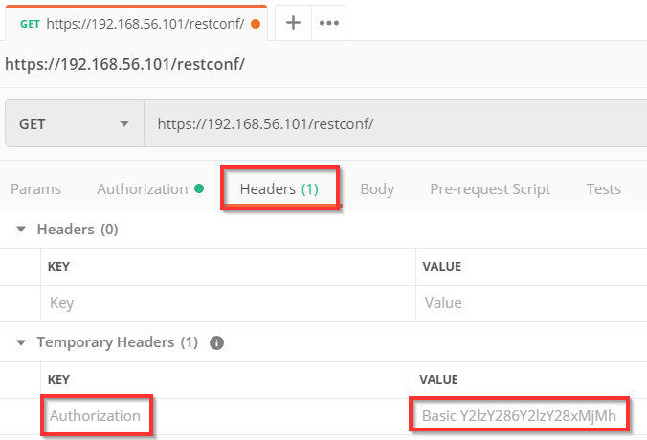

* + 1. Enter the additional Headers.
       1. Next, below the URL input field, select **Headers**.
       2. Under **Headers**, click the **New key** field under the **Key** column and enter **Content-Type** to define what is the encoding of data that are sent with Postman in the REST API request.
       3. Next again under **Headers**, click the **New key** field under the **Key** column and enter **Accept** to define in what encoding you wish to receive back the data replies from the REST API request.
       4. In the value columns, enter application/yang-data+json when sending or receiving data that are in JSON encoding. When sending or receiving data in XML encoding (default), use application/yang-data+xml.
    2. Send the request.
       1. Click **Send**.
       2. After a brief delay, you should see the response appear below the request information. Scroll down, if necessary to view the response data.
       3. When the **Accept** header was set to application/yang-data+json the response consists of JSON encoded data.
       4. Uncheck the **Accept** header, or change it to application/yang-data+xml (default behavior when no Accept header is defined) and click on **Send**. Nowthe response consists of XML encoded data:

**Note**: If there is an error, check the Status of the request. Check the meaning of the status code. 200 means success. A 404 error may mean that the URL was entered incorrectly. A 401 or 403 error could indicate a problem with the authentication, so check that the credentials are entered correctly.

1. Retrieve Interface Configuration
   * 1. Retrieve YANG data in XML.
        1. Duplicate the existing REST API request in Postman by right clicking on the request and selecting Duplicate Tab to create a new request with prefilled existing Headers:
        2. In the URL for the API endpoint, enter after the host and port portion:  
            /restconf/data/ietf-interfaces:interfaces to retrieve data defined in the **ietf-interfaces** YANG model in the **interfaces** container.
        3. Click **Send** to send the RESTCONF API request. With unchecked **Accept** header or the **Accept** header set to application/yang-data+xml, the result YANG data are returned in XML encoding.
        4. Check the Accept header and set it to application/yang-data+json to receive YANG data formatted in JSON encoding.
     2. Retrieve information about a single interface
        1. In the URL for the API endpoint, enter after the host and port portion:  
            /restconf/data/ietf-interfaces:interfaces/interface=Loopback1 to retrieve data for the **Loopback1** interface only.
        2. Click **Send** …
     3. Retrieve operation data
        1. Change the RESTCONF API Endpoint to retrieve operation and statistical data about the interfaces. You can use the “pyang” tool to discover what container in the **ietf-interfaces** YANG model includes the operational and stats data.

Question

* + - 1. What is the new URL?

In the ietf-interfaces module, the interfaces-state container contains operational and stats data.

URL: https://sandbox-iosxe-recomm-1.cisco.com/restconf/data/ietf-interfaces:interfaces-state

Type your answer here

1. Update Interface Configuration
   * + 1. Duplicate the existing REST API request in Postman by right clicking on the request and selecting Duplicate Tab to create a new request with prefilled existing Headers.
       2. In the URL for the API endpoint, change the method from **GET** to **PUT** and enter after the host and port portion: /restconf/data/ietf-interfaces:interfaces/interface=Loopback99 to create a new interface **Loopback99**.
       3. In the Body part of the request, enter the YANG data you want to apply to the device’s configuration (copy, paste and customize the JSON data from the previous GET request on Loopback1 – change the interface name and IP address).

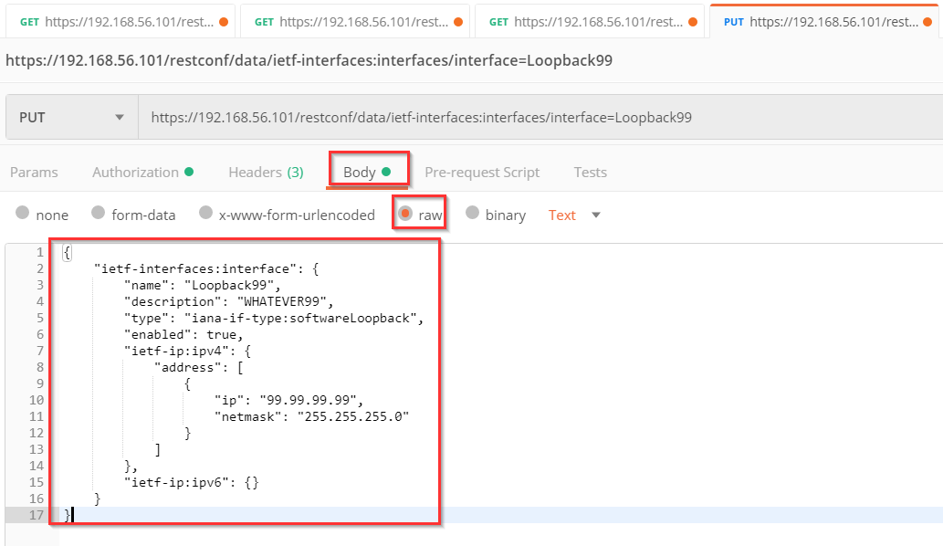

* + - 1. Click **Send** to create a new interface Loopback99 with the IP address 99.99.99.99/24.
      2. In the Output (scroll down), you should see the HTTP Error code **201 Created** indicating that the new interface has been created:
      3. Verify using the IOS CLI that the new Loopback99 interface has been created (sh ip int brief).
      4. Update the RESTCONF API request to delete the interface **Loopback99**.

Question

* + - 1. What changes were needed to be made in the RESTCONF request to delete the interface?

The method should be changed to “DELETE”, with the URL still being https://sandbox-iosxe-recomm-1.cisco.com/restconf/data/ietf-interfaces:interfaces/interface=Loopback99

This will remove interface Loopback99.